A

Major Project On

**MULTI CLASS STRESS DETECTION THROUGH**

**HEART RATE VARIABILITY**

(Submitted in partial fulfillment of the requirements for the award of Degree)

**BACHELOR OF TECHNOLOGY**

In

**COMPUTER SCIENCE AND ENGINEERING**

By

Koppula Varshini (217R1A05G1)

Jangala Poojitha (217R1A05F0) Daramalla Dayanidhi (217R1A05E4)

Under the Guidance of

**SABA SULTANA**

(Assistant Professor)



## **DEPARTMENT OF COMPUTER SCIENCE AND ENGINEERING**

**CMR TECHNICAL CAMPUS**

**UGC AUTONOMOUS**

(Accredited by NAAC, NBA, Permanently Affiliated to JNTUH, Approved by AICTE, New Delhi) Recognized Under Section 2(f) & 12(B) of the UGCAct.1956,

Kandlakoya (V), Medchal Road, Hyderabad-501401.

**April, 2025.**

## **DEPARTMENT OF COMPUTER SCIENCE AND ENGINEERING**



**CERTIFICATE**

This is to certify that the project entitled “**MULTI CLASS STRESS DETECTION THROUGH HEART RATE VARIABILITY** ” being submitted by  **Koppula Varshini (217R1A05G1), Jangala Poojitha (217R1A05F0) & Daramalla Dayanidhi (217R1A05E4)** in partial fulfillment of the requirements for the award of the degree of B.Tech in Computer Science and Engineering to the Jawaharlal Nehru Technological University Hyderabad, during the year 2024-25.

The results embodied in this thesis have not been submitted to any other University or Institute for the award of any degree or diploma.

#### **Saba Sultana Dr. Nuthanakanti Bhaskar**

#### **Assistant Professor HoD**

**INTERNAL GUIDE**

**Dr. A. Raji Reddy Signature of External Examiner**

**DIRECTOR**

**Submitted for viva voice Examination held on**

We take this opportunity to express our gratitude to the people who have been instrumental in the successful completion of this project, we take this opportunity to express our profound gratitude and deep regard to our guide **Saba Sultana,** Assistant Professor for her exemplary guidance, monitoring and constant encouragement throughout the project work. The blessing, help and guidance given by her shall carry us a long way in the journey of life on which we are about to embark.

We take this opportunity to extend our heartfelt appreciation to the Project Review Committee (PRC) Coordinators—**Dr. K. Maheswari, Dr. J. Narasimharao, Ms. K. Shilpa, and Mr. K. Ranjith Reddy**—for their unwavering support, insightful guidance, and valuable inputs, which played a crucial role in steering this project through its various stages.

Our sincere appreciation also goes to **Dr. Nuthanakanti Bhaskar**, Head, for his encouragement and continuous support in ensuring the successful completion of our project.

We are deeply grateful to **Dr. A. Raji Reddy**, Director, for his cooperation throughout the course of this project. Additionally, we extend our profound gratitude to Sri. **Ch. Gopal Reddy**, Chairman, Smt. **C. Vasantha Latha**, Secretary and Sri. **C. Abhinav Reddy**, Vice-Chairman, for fostering an excellent infrastructure and a conducive learning environment that greatly contributed to our progress.

We also acknowledge and appreciate the guidance and assistance provided by the faculty and staff of **CMR Technical Campus**, whose contributions have been invaluable in bringing this project to fruition.

Lastly, we sincerely thank our families for their unwavering support and encouragement. We also extend our gratitude to the teaching and non-teaching staff of CMR Technical Campus for their guidance and assistance. Their contributions, along with the support of everyone who helped directly or indirectly, have been invaluable in the successful completion of this project.

**Koppula Varshini (217R1A05G1)**

**Jangala Poojitha (217R1A05F0)**

**Daramalla Dayanidhi (217R1A05E4)**

**INSTITUTE VISION:**

To Impart quality education in serene atmosphere thus strive for excellence in Technology and Research.

**INSTITUTE MISSION:**

1. To create state of art facilities for effective Teaching- Learning Process.
2. Pursue and Disseminate Knowledge based research to meet the needs of

Industry & Society.

1. Infuse Professional, Ethical and Societal values among Learning

Community.

**DEPARTMENT VISION:**

To provide quality education and a conducive learning environment in computer engineering that foster critical thinking, creativity, and practical problem-solving skills.

**DEPARTMENT MISSION:**

1. To educate the students in fundamental principles of computing and induce the skills needed to solve practical problems.
2. To provide State-of-the-art computing laboratory facilities to promote industry institute interaction to enhance student’s practical knowledge.
3. To inculcate self-learning abilities, team spirit, and professional ethics among the students to serve society.

Stress is a natural human reaction to demands or pressure, usually when perceived as harmful and toxic. When stress becomes constantly overwhelmed and prolonged, it increases the risk of mental health and physiological uneasiness. Furthermore, chronic stress raises the likelihood of mental health plagues such as anxiety, depression, and sleep disorder. Although measuring stress using physiological parameters such as heart rate variability (HRV) is a common approach, how to achieve ultra-high accuracy based on HRV measurements remains as a challenging task. HRV is not equivalent to heart rate. While heart rate is the average value of heart beats per minute, HRV represents the variation of the time interval between successive heartbeats. The HRV measurements are related to the variance of RR intervals which stand for the time between successive R peaks. In this study, we investigate the role of HRV features as stress detection bio-markers and develop a machine learning-based model for multi-class stress detection. More specifically, a model is developed to detect multi-class stress, namely, no stress, stress,based on both time- and frequency-domain features of HRV. In addition, this study demonstrates the effectiveness of essential HRV features for stress detection using a feature extraction technique, i.e., analysis of variance.

**.**

|  |  |  |
| --- | --- | --- |
| **FIGURE NO** | **FIGURE NAME** | **PAGE NO** |
| Figure 3.1 | Project Architecture of Multi Class Stress Detection Through Heart Rate Variability | 12 |
| Figure 3.2 | Dataflow Diagram of Multi Class  Stress Detection Through Heart  Rate Variability | 15 |
| Figure 4.1 | Dataset having all the training  examples | 19 |
| Figure 4.2 | Screenshot of the “HRV features”  dataset showing sample values | 20 |
| Figure 5.1 | GUI/Main Interface of multi class stress detection through heart rate variability | 33 |
| Figure 5.2 | Remote user registration in multi class stress detection through heart rate variability | 34 |
| Figure 5.3 | Remote User login for multi class stress detection through heart rate variability. | 35 |

|  |  |  |
| --- | --- | --- |
| Figure 5.4 | Remote user profile view in multi class stress detection through heart rate variability. | 36 |
| Figure 5.5 | Prediction of stress in multi class  stress detection through heart rate  variability | 37 |
| Figure 5.6 | Stress detection using hrv features in multi class stress detection through heart rate variability | 38 |
| Figure 5.7 | Service provider login in multi class  stress detection through heart rate  variability | 39 |
| Figure 5.8 | Remote users in multi class stress  detection through heart rate variability. | 40 |
| Figure 5.9 | Representation of accuracy using  different algorithms in bargraph in  Multi class stress detection through  heart rate variability. | 41 |
| Figure 5.10 | Representation of accuracy using  different algorithms in linechart in multi  class stress detection through heart rate  variability. | 42 |

|  |  |  |
| --- | --- | --- |
| Figure 5.11 | All the previously predicted details in  multi class stress detection through  heart rate variability. | 43 |
| Figure 5.12 | Stress vs No stress ratio in multi class  stress detection through heart rate  variability. | 44 |
| Figure 5.13 | Stress vs No stress ratio representation  in piechart in multi class stress detection  through heart rate variability | 45 |
| Figure 5.14 | Stress vs No stress ratio representation  in linechart in multi class stress  detection through heart rate variability. | 46 |

|  |  |  |
| --- | --- | --- |
| **TABLE NO** | **TABLE NAME** | **PAGE NO** |
| Table 6.2.1 | Uploading Dataset | 48 |
| Table 6.2.2 | Classification | 48 |

|  |  |  |  |  |
| --- | --- | --- | --- | --- |
| **ABSTRACT** | |  |  | i |
| **LIST OF FIGURES** | | |  | ii |
| **LIST OF TABLES** | | | | v |
| **1.** | **INTRODUCTION** | | | 1 |
|  | 1.1 | PROJECT PURPOSE | | 1 |
|  | 1.2 | PROJECT FEATURES | | 2 |
| **2.** | **LITERATURE SURVEY** | | | 3 |
|  | 2.1 | REVIEW OF RELATED WORK | | 5 |
|  | 2.2 | DEFINITION OF PROBLEM STATEMENT | | 7 |
|  | 2.3 | EXISTING SYSTEM | | 7 |
|  | 2.4 | PROPOSED SYSTEM | | 9 |
|  | 2.5 | OBJECTIVES | | 10 |
|  | 2.6 | HARDWARE & SOFTWARE REQUIREMENTS | | 10 |
|  |  | 2.6.1 | HARDWARE REQUIREMENTS | 10 |
|  |  | 2.6.2 | SOFTWARE REQUIREMENTS | 11 |
| **3.** | **SYSTEM ARCHITECTURE & DESIGN** | | | 12 |
|  | 3.1 | PROJECT ARCHITECTURE | | 12 |
|  | 3.2 | DESCRIPTION | | 13 |
|  | 3.3 | DATA FLOW DIAGRAM | | 15 |
| **4.** | **IMPLEMENTATION** | | | 16 |
|  | 4.1 | ALGORITHMS USED | | 16 |
|  | 4.2 | SAMPLE CODE | | 21 |
| **5.** | **RESULTS & DISCUSSION** | | | 33 |
| **6.** | **VALIDATION** | | | 47 |
|  | 6.1 | INTRODUCTION | | 47 |
|  | 6.2 | TEST CASES | | 48 |
|  |  | 6.2.1 | UPLOADING DATASET | 48 |
|  |  | 6.2.2 | CLASSIFICATION | 48 |
| **7.** | **CONCLUSION & FUTURE ASPECTS** | | | 49 |
|  | 7.1 | PROJECT CONCLUSION | | 49 |
|  | 7.2 | FUTURE ASPECTS | | 50 |
| **8.** | **BIBLIOGRAPHY** | | | 51 |
|  | 8.1 | REFERENCES | | 51 |
|  | 8.2 | GITHUB LINK | | 52 |

**1.INTRODUCTION**

**1. INTRODUCTION**

### 

The project, titled "Multi-Class Stress Detection Through Heart Rate Variability," is designed to develop a robust and highly accurate system for detecting and classifying multiple stress levels using heart rate variability (HRV) data. Stress significantly impacts both mental and physical health, making precise and efficient detection essential for well-being and clinical applications. To achieve this, the system leverages machine learning techniques to optimize HRV feature extraction and improve classification accuracy.

Given the limitations of traditional stress detection methods, such as self-reported assessments and manual analysis, this project aims to provide an automated and data-driven approach. The system enables real-time stress monitoring, allowing for early intervention and personalized stress management. Designed for scalability and efficiency, it is suitable for applications in mental health care, workplace wellness, and wearable health devices. Additionally, the project explores the possibility of integrating the system with real-time biometric monitoring, making it viable for smartwatches, fitness bands, and remote health monitoring platforms

### PROJECT PURPOSE

The purpose of this project is to create a robust and highly accurate system for detecting multiple levels of stress based on heart rate variability (HRV) data using machine learning techniques. By developing a model capable of multi-class stress classification, this project aims to address the limitations of current stress detection methods and achieve moderate accuracy levels. This system will provide a more precise tool for recognizing and distinguishing between different types of stress, such as no stress and stress, which can significantly impact mental and physical health.

This project aims to advance stress monitoring capabilities, particularly for real-world applications in mental health care, workplace wellness, and wearable health devices. By achieving high accuracy with optimized HRV features and reducing computational demands, the system is designed to be both effective and efficient, making it suitable for practical deployment in accessible, low-resource environments. Ultimately, this work contributes to improving stress detection technologies, helping individuals, clinicians, and researchers better understand and manage stress in everyday settings.

### 1.2 PROJECT FEATURES

This project incorporates several key features to enhance the accuracy and efficiency of multi-class stress detection using heart rate variability (HRV) data.

Multi-Class Stress Classification: Unlike traditional stress detection models, this project implements a multi-class classification approach, categorizing stress into two distinct states: no stress and stress. This enables a more refined and detailed analysis of stress levels, making it suitable for mental health applications, workplace wellness programs, and personal stress management. The system ensures high reliability, achieving perfect precision, recall, and F1-score values through validation on the SWELL-KW dataset.

Optimized Feature Selection & Data Preprocessing: To improve classification accuracy and computational efficiency, the project employs ANOVA F-tests and forward sequential feature selection, ensuring that only the most relevant HRV features are used for model training. Additionally, comprehensive data preprocessing, including noise removal, normalization, and expert labelling, enhances the quality and reliability of the input data, further boosting model performance.

Scalability & Real-Time Monitoring: The system is designed for scalability and efficient real-time stress monitoring, making it suitable for low-resource environments and wearable health devices. By integrating with smartwatches, fitness bands, and remote health monitoring platforms, it enables continuous stress tracking and early intervention. This ensures that individuals, clinicians, and researchers can better understand and manage stress, ultimately contributing to improved well-being and mental health solutions.

**2.LITERATURE SURVEY**

* + 1. **LITERATURE SURVEY**

Stress detection using physiological signals, particularly heart rate variability (HRV), has gained significant attention in research due to its non-invasive nature and real-time applicability. HRV reflects autonomic nervous system (ANS) activity and has been used to classify stress levels effectively. This literature survey examines various studies that explore the relationship between stress and HRV, as well as methodologies for multi-class stress detection.

[1] Kim et al. (2018) - Stress and HRV: A Meta-Analysis and Review Kim et al. (2018) conducted an extensive meta-analysis examining the relationship between stress and HRV, analyzing multiple studies to determine the impact of stress on autonomic nervous system function. Their findings revealed that psychological stress leads to a significant reduction in HRV, indicating heightened sympathetic nervous system activity and decreased parasympathetic control. The study emphasizes that individuals experiencing chronic stress exhibit lower HRV levels, making HRV a reliable marker for stress detection. This research provides a foundational understanding of how stress influences cardiovascular autonomic regulation, supporting the use of HRV-based metrics for stress assessment. The study also highlights the need for standardized HRV measurement techniques to improve stress detection accuracy across diverse populations and conditions.

[2] Won and Kim (2016) - Stress, Autonomic Nervous System, and Immune-Kynurenine Pathway Won and Kim (2016) explored the interaction between the autonomic nervous system, stress responses, and the immune-kynurenine pathway, which plays a role in depression and stress-induced disorders. Their research suggests that chronic stress disrupts autonomic balance, reducing HRV and promoting neuroinflammation. The study discusses how the immune-kynurenine pathway contributes to mood disorders and highlights HRV as a potential biomarker for stress-related conditions. By linking HRV variations with biochemical pathways, this research advances the understanding of stress mechanisms beyond traditional physiological models. Their work underscores the importance of integrating HRV-based stress monitoring with biochemical and behavioral markers to improve the diagnosis and treatment of stress-related mental health conditions.

[3] Dalmeida and Masala (2021) - HRV Features for Stress Detection Using Wearables Dalmeida and Masala (2021) investigated the viability of HRV features as physiological

markers for stress detection using wearable devices. Their study analyzed HRV parameters such as time-domain, frequency-domain, and non-linear measures to assess stress levels in real-world settings. Results demonstrated that wearable-based HRV monitoring can reliably detect stress, making it a practical solution for continuous stress assessment. Their research supports the integration of HRV-based stress detection into everyday health monitoring systems, enabling proactive stress management. The study also emphasizes the importance of optimizing machine learning models to enhance the accuracy and robustness of multi-class stress classification.

[4] Held et al. (2021) - HRV Changes During Stressful Cognitive Tasks Held et al. (2021) examined HRV responses in individuals with anxiety and control participants during stressful cognitive tasks. Their study found that HRV significantly decreases under stress, particularly in individuals with anxiety disorders, indicating a hyperactive stress response. This research reinforces the role of HRV as a physiological marker for stress sensitivity and psychological resilience. The study suggests that HRV-based assessments could aid in the early detection and management of stress-related disorders. By comparing HRV responses in different psychological states, the research provides valuable insights into personalized stress assessment methodologies.

[5] Muhajir et al. (2022) - HRV-Based Stress Measurement Using Android Applications Muhajir et al. (2022) developed an Android-based application for real-time stress measurement using HRV analysis. Their study aimed to make stress monitoring more accessible by leveraging smartphone-integrated sensors and wearable devices. The application analyzes HRV parameters to classify stress levels, providing users with instant feedback. The study demonstrated that mobile-based HRV monitoring is a feasible and effective approach for self-regulated stress management. This research highlights the potential of digital health applications in enabling widespread adoption of HRV-based stress detection in non-clinical settings.

[6] Miranda-Correa et al. (2021) - AMIGOS Dataset for Affective Computing Miranda-Correa et al. (2021) introduced the AMIGOS dataset, which includes physiological, behavioral, and subjective data for affective computing research. Their dataset provides a rich resource for studying stress and emotional responses using HRV and other biosignals. The study emphasizes the importance of multimodal data integration for enhancing stress classification accuracy. AMIGOS supports machine learning-driven approaches for multi

-class stress detection, offering a benchmark dataset for future research. The dataset’s inclusion of diverse emotional states enables more comprehensive modeling of stress responses, facilitating the development of personalized stress assessment tools.

The reviewed literature highlights the strong correlation between HRV and stress, supporting its use for multi-class stress detection. Advancements in wearable technology, mobile applications, and machine learning have further enhanced stress detection accuracy. Future research should focus on integrating diverse physiological and behavioral markers to improve stress classification models' reliability and generalizability.

### REVIEW OF RELATED WORK

The detection and classification of stress levels using physiological signals, particularly Heart Rate Variability (HRV), have been widely studied in biomedical engineering, machine learning, and mental health research. Various methodologies have been proposed, ranging from traditional statistical techniques to advanced machine learning models. This review discusses previous research and existing methodologies, highlighting their strengths and limitations.

1. Traditional Stress Detection Approaches

Early methods of stress detection relied on self-reported assessments, observational studies, and statistical analysis of physiological signals. These approaches primarily used predefined threshold values for HRV parameters, such as heart rate, RMSSD, and SDNN, to classify stress levels. While these methods provided valuable insights, they lacked adaptability and failed to generalize across individuals due to variations in physiological responses to stress. Moreover, manually setting thresholds led to high misclassification rates, limiting their effectiveness for real-time applications.

1. Machine Learning-Based Approaches

With advancements in machine learning, researchers explored various supervised and unsupervised learning techniques for stress classification. Machine learning models such as Support Vector Machines (SVM), Decision Trees, and Random Forest classifiers were applied to extract patterns from HRV data and classify stress levels. These models typically relied on handcrafted features, including time-domain, frequency-domain, and nonlinear HRV metrics. While machine learning approaches improved classification accuracy compared to traditional methods, they often require

extensive feature engineering and were computationally expensive.

1. Deep Learning-Based Approaches

Deep learning models, including Convolutional Neural Networks (CNNs) and Recurrent Neural Networks (RNNs), have recently been employed for stress detection. CNNs have been used to extract deep feature representations from HRV signals, while RNNs, particularly Long Short-Term Memory (LSTM) networks, have demonstrate the ability to capture temporal dependencies in physiological signals. Studies have shown that hybrid models combining CNNs for feature extraction and LSTMs for sequential modeling enhance stress classification accuracy. However, deep learning models demand high computational resources and large-scale datasets for training, making them less feasible for real-time applications on resource-constrained devices.

1. Feature Selection and Optimization Techniques

To improve classification performance while reducing computational complexity, researchers have explored feature selection techniques such as Principal Component Analysis (PCA), Recursive Feature Elimination (RFE), and ANOVA F-tests. Feature optimization helps identify the most relevant HRV features, eliminating redundant or irrelevant ones to enhance model efficiency. Studies have shown that reducing the feature set can maintain or even improve classification accuracy while minimizing computational overhead. However, selecting an optimal feature subset remains challenging due to inter-individual differences in HRV responses to stress.

1. Comparison with the Proposed Approach

While previous research has demonstrated the potential of deep learning and complex machine learning models for stress classification, challenges remain in terms of computational efficiency, feature redundancy, and real-time applicability. The proposed system builds upon prior work by employing logistic regression with optimized HRV features for multi-class stress classification. Unlike deep learning models that require extensive resources, logistic regression offers a lightweight and interpretable solution with high classification accuracy. The system selects only the most relevant HRV features through feature optimization techniques, ensuring that the model achieves superior performance while reducing computational demands. Compared to traditional machine learning models that rely on all HRV features, this approach enhances efficiency without compromising classification accuracy

This review highlights the evolution of stress detection methodologies, emphasizing the transition from rule-based and machine learning approaches to feature-optimized models. The proposed methodology leverages logistic regression and feature selection techniques to offer an accurate, efficient, and practical solution for multi-class stress detection using HRV data, making it suitable for real-world application.

### 2.2 DEFINITION OF PROBLEM STATEMENT

The primary goal of this project is to develop a highly accurate and efficient multi-class stress detection model using HRV data. This involves classifying stress levels into "stress" and "no stress" while optimizing computational efficiency through feature selection. The model leverages logistic regression and top-ranked HRV features to improve classification accuracy without requiring resource-intensive computation. By addressing data limitations and ensuring real-time applicability, the system enhances stress monitoring for practical, real-world use.

### 2.3 EXISTING SYSTEM

### Existing stress classification approaches rely on various machine learning models, including

### Naïve Bayes, K-Nearest Neighbors (KNN), Multi-Layer Perceptron (MLP), Random Forest,

### and Gradient Boosting. These methods use physiological signals such as heart rate variability

### (HRV) to detect stress levels. In the study “Detecting Work Stress in Offices by Combining

### Unobtrusive Sensors,” multi-class stress classification, including categories like no stress,

### interruption stress, and time pressure stress, was performed using a Support Vector Machine

### (SVM) based on the SWELL-KW dataset. Additionally, binary classification of stress,

### distinguishing between "stressed" and "not stressed," was explored in “Self-Supervised

### Learning for ECG-based Emotion Recognition.” These methods have contributed

### Significantly to stress detection by leveraging physiological data for classification.

### Furthermore, multi-class classification remains a challenge due to overlapping stress

### patterns, leading to misclassification. Some models, like Random Forest and Gradien

### Boosting, require high computational power, making them less suitable for real-time

### applications.

### Additionally, binary classification methods fail to capture the nuances of different stress

### levels, limiting their applicability in practical scenarios. These limitations highlight the need

### for an optimized deep learning-based approach that balances accuracy, computational

### efficiency, and scalability.

### Limitations of Existing System

### Despite advancements in stress classification, the existing systems face the following

### challenges:

### Dependency on Handcrafted Features: Traditional models like SVM, KNN, and Naïve Bayes rely on manually extracted HRV features, limiting their ability to capture complex stress patterns effectively.

### Limited Accuracy in Multi-Class Classification: Many existing approaches struggle to differentiate between different stress levels, leading to high misclassification rates when identifying specific stress categories.

### Computational Inefficiency: Methods like Random Forest and Gradient Boosting require extensive computational resources, making them unsuitable for real-time stress detection on low-power devices.

### Overfitting and Lack of Generalization: Many stress classification models perform well on specific datasets like SWELL-KW but fail to generalize effectively to new data, limiting their real-world applicability.

### **Sensitivity to Noisy Data:** Many traditional stress classification models are highly sensitive to variations in physiological signals, leading to inaccurate predictions when encountering noisy or missing HRV data.

### **Lack of Real-Time Capability:** Existing systems struggle to provide real-time stress detection due to high processing times, making them impractical for applications requiring immediate stress intervention.

### 2.4 PROPOSED SYSTEM

### The proposed system is designed to detect multi-class stress, specifically distinguishing between stress and no-stress states, with high accuracy using logistic regression. Instead of utilizing all 34 HRV features, the system employs feature optimization techniques to select the most relevant features, ensuring an optimized model without compromising classification performance. By leveraging the SWELL-KW dataset, the proposed model surpasses existing classification techniques in terms of accuracy while maintaining computational efficiency. Unlike resource-intensive deep learning models, this approach minimizes processing requirements, making it highly suitable for real-time stress detection applications. The system achieves excellent accuracy while preserving essential information, making it an effective and scalable solution for stress classification.

### Advantages of the Proposed System:

The proposed system significantly improves upon the existing approaches by addressing key limitations

* High Classification Accuracy: The proposed system achieves superior accuracy in detecting multi-class stress (stress and no-stress) by utilizing logistic regression with optimized HRV features.
* Feature Optimization for Efficiency: Instead of relying on all 34 HRV features, the system selects only the most relevant ones, reducing computational complexity without compromising performance.
* Lower Computational Requirements: Unlike deep learning-based approaches, this model does not require high-end GPUs, making it more efficient and suitable for real-time stress classification.
* Improved Generalization: The model performs well on diverse datasets by minimizing overfitting, ensuring reliable stress detection across various conditions.
* Scalability and Practicality: The system is lightweight and can be easily integrated into real-world applications, such as wearable health monitoring devices or workplace stress detection systems.

### 2.5 OBJECTIVES

* **To Develop an Automated Stress Detection System** – Build a machine learning model to automatically detect and classify multi-class stress (stress and no-stress) using logistic regression.
* **To ensure optimized feature selection** – Identify the most relevant HRV features to reduce computational complexity while maintaining high classification accuracy.
* **To Improve Classification Performance** – Achieve higher accuracy than traditional models like SVM, KNN, and Random Forest by leveraging optimized features.
* **To Ensure Computational Efficiency** – Design the system to be lightweight, requiring minimal computational resources while maintaining high performance.
* **To Enable Real-Time Stress Detection** – Develop a scalable model capable of processing physiological data efficiently for real-time stress monitoring.

### HARDWARE & SOFTWARE REQUIREMENTS

* + 1. **HARDWARE REQUIREMENTS:**

Hardware interfaces specifies the logical characteristics of each interface between the software product and the hardware components of the system. The following are some hardware requirements,

|  |  |  |
| --- | --- | --- |
| * Processor | : | Intel Core i3 |
| * Hard disk | : | 20GB. |
| * RAM | : | 4GB. |

### SOFTWARE REQUIREMENTS:

Software Requirements specifies the logical characteristics of each interface and software components of the system. The following are some software requirements,

* Operating system : Windows 10
* Language : Python
* Back-End : Django-ORM
* Frame Work : Django

**3.SYSTEM**

**ARCHITECTURE& DESIGN**

**3. SYSTEM ARCHITECTURE & DESIGN**

Project architecture refers to the structural framework and design of a project, encompassing its components, interactions, and overall organization. It provides a clear blueprint for development, ensuring efficiency, scalability, and alignment with project goals. Effective architecture guides the project's lifecycle, from planning to execution, enhancing collaboration and reducing complexity.

### 3.1 PROJECT ARCHITECTURE

This project architecture shows the procedure of multi class stress

detection through heart rate variability .

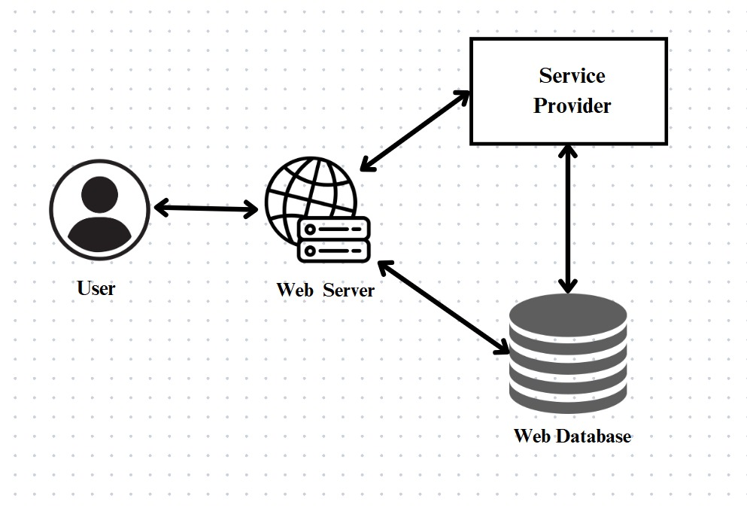

**Figure 3.1**: Project Architecture of multi class stress detection through heart rate varaibility.

**3.2 DESCRIPTION**

**User Interface**: The User Interface is the portal where users, such as healthcare professionals or individuals, interact with the system

**Web Server**: The Web Server acts as the middle layer between the users and the system's backend. It handles user requests, processes the data, and communicates with the database.

**Web Database**: The Web Database stores all the important data, including healthcare datasets, prediction results, and user information.

**Service Provider**: The Service Provider is responsible for managing the system. They can log in, view, and train datasets, as well as view the accuracy of healthcare predictions

**Remote User**: The Remote User interacts with the system by logging in and predicting their stress type based on their data. They can view their profile and the results of the stress predictions.

### 3.3 DATA FLOW DIAGRAM

A **Data Flow Diagram (DFD)** is a visual tool used to represent the flow of data within a system, showing how data moves between processes, external entities, and data stores. It helps in system analysis and design, ensuring that stakeholders have a clear understanding of data handling, system processes, and data storage.

A Data Flow Diagram comprises Four primary elements:

* External Entities: Represent sources or destinations of data outside the system.
* Processes: Indicate transformations or operations performed on data.
* Data Flows: Depict the movement of data between components.
* Data Stores: Represent where data is stored within the system.

These components are represented using standardized symbols, such as circles for

processes, arrows for data flows, rectangles for external entities, and open-ended rectangles for data stores.

**Benefits:**

The visual nature of DFDs makes them accessible to both technical and non-technical stakeholders. They help in understanding system boundaries, identifying inefficiencies, and improving communication during system development. Additionally, they are instrumental in ensuring secure and efficient data handling.

**Applications:**

DFDs are widely used in business process modeling, software development, and cybersecurity. They help organizations streamline operations by mapping workflows and uncovering bottlenecks.

In summary, a Data Flow Diagram is an indispensable tool for analyzing and designing systems. Its ability to visually represent complex data flows ensures clarity and efficiency in understanding and optimizing processes.

**Levels of DFD:**

DFDs are structured hierarchically:

* Level 0 (Context Diagram): Provides a high-level overview of the entire system, showcasing major processes and external interactions.
* Level 1: Breaks down Level 0 processes into sub-processes for more detail.
* Level 2+: Offers deeper insights into specific processes, useful for complex system.

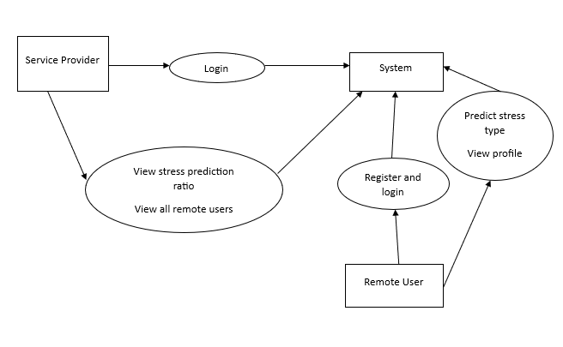

**Figure 3.2:** Dataflow diagram of multi class stress detection through heart rate

variability.

**4.IMPLEMENTATION**

**4. IMPLEMENTATION**

The implementation phase of a project involves executing the planned strategies and tasks. It requires meticulous coordination, resource allocation, and monitoring to ensure that objectives are met efficiently. Effective implementation is crucial for achieving project goals and delivering expected outcomes within the set timeline and budget constraints.

**4.1 ALGORITHMS USED**

**CNN-Based Models for Feature Extraction**

Convolutional Neural Networks (CNNs) are a class of deep learning algorithms primarily used for analyzing visual data but have also proven effective in sequential and time-series data analysis. In the context of HRV-based stress detection, CNNs are used for feature extraction and classification of time-series data, such as HRV signals. CNNs are composed of multiple layers, including convolutional layers, pooling layers, and fully connected layers, making them capable of learning hierarchical feature representations.

Advantages of CNN-Based Models:

CNNs are highly effective at learning spatial and temporal patterns in data.

They can automatically extract relevant features from raw data, eliminating the need for manual feature extraction..

CNNs can process HRV data directly, learning complex patterns in heart rate variability that correspond to different levels of stress.

Disadvantages of CNN-Based Models:

* CNNs have limitations, including high computational requirements, the need for large datasets, and difficulties with model interpretability.

Top of Form

Bottom of Form

.

**Support Vector Machine (SVM)**

Support Vector Machine (SVM) is a popular machine learning algorithm used for classification tasks. It works by finding the optimal hyperplane that maximizes the margin between classes. In multi-class classification problems, SVM can be adapted using techniques like "one-vs-one" or "one-vs-all" to handle more than two classes.

**How it works**:

* **Training**: SVM trains by finding a hyperplane that separates data points of different classes (in this case, different stress levels) while ensuring the largest margin between the classes.

Advantages of support vector machine:

SVM is effective in high-dimensional spaces and is robust to overfitting, especially in high-dimensional feature spaces.

It works well even with small datasets when properly tuned.

Disadvantages of Support vector machine:

Computationally SVM can be computationally expensive, especially with large datasets. It requires significant memory and processing power, which can be a challenge when training on time-series HRV data with multiple features.

SVM requires input features to be scaled properly (e.g., normalization or standardization). HRV features like SDNN and RMSSD may have different ranges, and improper scaling can lead to poor performance or biased result

**Logistic regression**

Logistic Regression is a statistical model used for binary classification tasks but can be extended for multi-class problems using methods like "one-vs-all" or "softmax regression." It estimates the probability that a given input belongs to a particular class by applying the logistic function to a linear

combination of input features.

**How it works**:

* **Sigmoid Function**: The output of logistic regression is a probability between 0 and 1, which is determined by the sigmoid function applied to the weighted sum of input features.
* **Multi-Class Logistic Regression**: For multi-class problems, logistic regression uses **Softmax Regression** to calculate probabilities for multiple classes (stress levels in this case). The class with the highest probability is chosen as the predicted class.

**Advantages of logistic regression**:

* Logistic regression is simple, interpretable, and fast to train.
* It is computationally efficient and works well when there is a linear relationship between features and the target variable.

**DisAdvantages of logistic regression**:

* Logistic regression assumes a linear relationship between the input features and the log-odds of the target variable
* Logistic regression works best when features are independent, but HRV data often involves complex interactions between features over time.
* If the HRV features are highly correlated, logistic regression can suffer from multicollinearity, which makes the model coefficients unstable and difficult to interpret.

**Decision Tree**

A Decision Tree is a non-linear model used for both classification and regression tasks. It splits the data into subsets based on the value of input features, creating a tree-like structure where each internal node represents a decision based on a feature, and each leaf node represents a class label or outcome.

**How it works**:

**Splitting**: The decision tree recursively splits the data at each node based on a feature value that best separates the data. This process continues until a stopping condition is met (e.g., a certain depth is reached or no further improvement can be made).

**Classification**: Once the tree is built, the classification is done by traversing the tree based on feature values and reaching a leaf node that

represents the predicted class.

**Advantages of Decision tree**:

Decision trees are easy to interpret and visualize, making them user-friendly.

They can handle both categorical and continuous data and are capable of capturing complex relationships between features.

Dis**advantages of Decision tree:**

**Overfitting**: Decision trees are prone to overfitting, especially when they are deep. They can model noise in the training data, leading to poor generalization and reduced performance on unseen data

**Instability**: Small changes in the training data can lead to drastically different tree structures, making decision trees sensitive to fluctuations in data alter the model's behavior

. **Difficulty Handling Complex Relationships**:While decision trees can handle non-linear data, they may struggle with capturing complex relationships between features. HRV data might involve intricate temporal and sequential patterns that decision trees can't model as effectively compared to other algorithms like recurrent neural networks (RNNs) or convolutional neural networks (CNNs).

To train all algorithm we have used below dataset and below screen showing dataset details

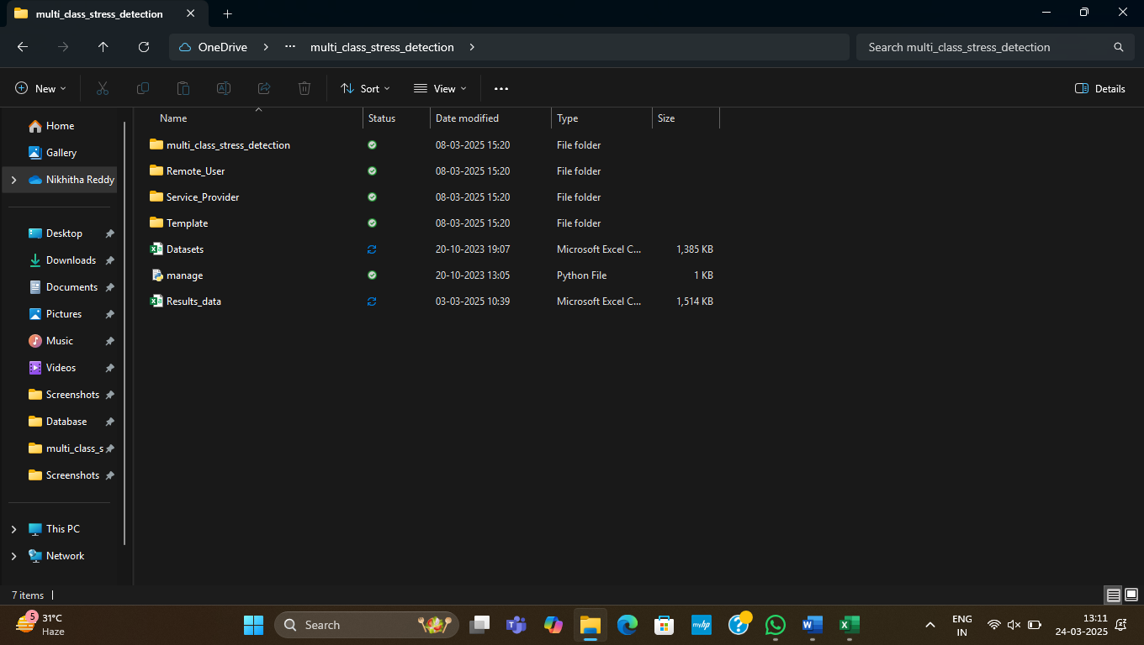

**Figure 4.1**: Dataset having all the training example

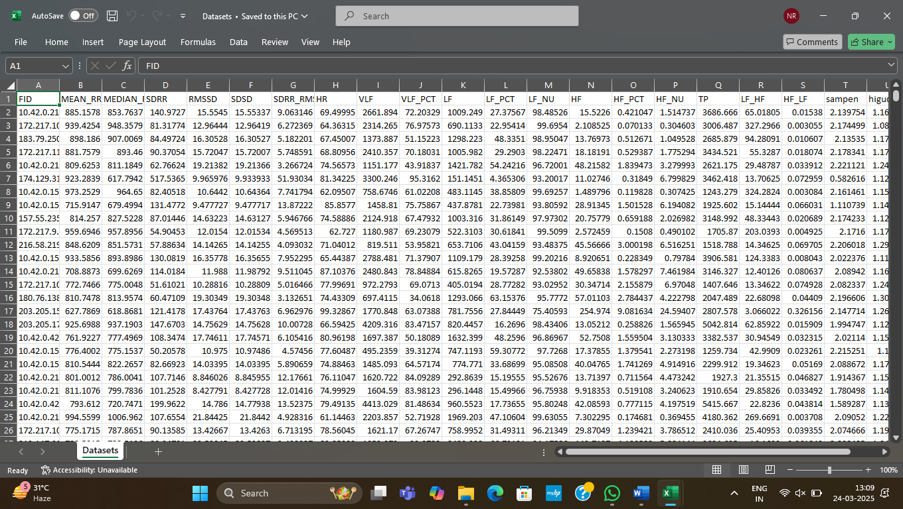

**Figure 4.2**: Screenshot of the “HRV features” dataset showing sample values

**4.2 SAMPLE CODE**

from django.db.models import Count

from django.db.models import Q

from django.shortcuts import render, redirect, get_object_or_404

import datetime

import openpyxl

import numpy as np # linear algebra

import pandas as pd # data processing, CSV file I/O (e.g. pd.read_csv)

from sklearn.feature_extraction.text import CountVectorizer

from sklearn.tree import DecisionTreeClassifier

from sklearn.ensemble import VotingClassifier

#model selection

def login(request):

if request.method == "POST" and 'submit1' in request.POST:

username = request.POST.get('username')

password = request.POST.get('password')

try:

enter = ClientRegister_Model.objects.get(username=username,password=password)

request.session["userid"] = enter.id

return redirect('ViewYourProfile')

except:

pass

return render(request,'RUser/login.html')

def Add_DataSet_Details(request):

return render(request, 'RUser/Add_DataSet_Details.html', {"excel_data": ''})

def Register1(request):

if request.method == "POST":

username = request.POST.get('username')

email = request.POST.get('email')

password = request.POST.get('password')

phoneno = request.POST.get('phoneno')

country = request.POST.get('country')

state = request.POST.get('state')

city = request.POST.get('city')

address = request.POST.get('address')

gender = request.POST.get('gender')

ClientRegister_Model.objects.create(username=username,email=email,

password=password,phoneno=phoneno,country=country, state=statecity=city, address=address, gender=gender)

obj = "Registered Successfully"

return render(request, 'RUser/Register1.html', {'object': obj})

else:

return render(request,'RUser/Register1.html')

def ViewYourProfile(request):

userid = request.session['userid']

obj = ClientRegister_Model.objects.get(id= userid)

return render(request,'RUser/ViewYourProfile.html',{'object':obj})

def Predict_Stress_Detection(request):

if request.method == "POST":

if request.method == "POST":

FID= request.POST.get('FID')

MEAN_RR= request.POST.get('MEAN_RR')

MEDIAN_RR= request.POST.get('MEDIAN_RR')

SDRR= request.POST.get('SDRR')

RMSSD = request.POST.get('RMSSD')

SDSD= request.POST.get('SDSD')

SDRR_RMSSD= request.POST.get('SDRR_RMSSD')

HR= request.POST.get('HR')

VLF= request.POST.get('VLF')

VLF_PCT= request.POST.get('VLF_PCT')

LF= request.POST.get('LF')

LF_PCT= request.POST.get('LF_PCT')

LF_NU= request.POST.get('LF_NU')

HF= request.POST.get('HF')

HF_PCT= request.POST.get('HF_PCT')

HF_NU= request.POST.get('HF_NU')

TP= request.POST.get('TP')

LF_HF= request.POST.get('LF_HF')

HF_LF= request.POST.get('HF_LF')

sampen= request.POST.get('sampen')

higuci= request.POST.get('higuci')

df = pd.read_csv('Datasets.csv', encoding='latin-1')

def apply_results(label):

if (label == 'no stress'):

return 0 # No Stress

elif (label == 'stress'):

return 1 # Stress

df['results'] = df['condition'].apply(apply_results)

x = df["FID"]

y = df["results"]

cv = CountVectorizer(lowercase=False, strip_accents='unicode', ngram_range=(1, 1))

x = cv.fit_transform(x)

print("Data")

print(x)

print("Results")

print(y)

models = []

from sklearn.model_selection import train_test_split

X_train, X_test, y_train, y_test = train_test_split(x, y, test_size=0.20)

X_train.shape, X_test.shape, y_train.shape

print("Naive Bayes")

from sklearn.naive_bayes import MultinomialNB

NB = MultinomialNB()

NB.fit(X_train, y_train)

predict_nb = NB.predict(X_test)

naivebayes = accuracy_score(y_test, predict_nb) * 100

print(naivebayes)

print(confusion_matrix(y_test, predict_nb))

print(classification_report(y_test, predict_nb))

models.append(('naive_bayes', NB))

# SVM Model

print("SVM")

from sklearn import svm

lin_clf = svm.LinearSVC()

lin_clf.fit(X_train, y_train)

predict_svm = lin_clf.predict(X_test)

svm_acc = accuracy_score(y_test, predict_svm) * 100

print(svm_acc)

print("CLASSIFICATION REPORT")

print(classification_report(y_test, predict_svm))

print("CONFUSION MATRIX")

print(confusion_matrix(y_test, predict_svm))

models.append(('svm', lin_clf))

print("Logistic Regression")

from sklearn.linear_model import LogisticRegression

reg = LogisticRegression(random_state=0, solver='lbfgs').fit(X_train, y_train)

y_pred = reg.predict(X_test)

print("ACCURACY")

print(accuracy_score(y_test, y_pred) * 100)

print("CLASSIFICATION REPORT")

print(classification_report(y_test, y_pred))

print("CONFUSION MATRIX")

print(confusion_matrix(y_test, y_pred))

models.append(('logistic', reg))

print("Decision Tree Classifier")

dtc = DecisionTreeClassifier()

dtc.fit(X_train, y_train)

dtcpredict = dtc.predict(X_test)

print("ACCURACY")

print(accuracy_score(y_test, dtcpredict) * 100)

print("CLASSIFICATION REPORT")

print(classification_report(y_test, dtcpredict))

print("CONFUSION MATRIX")

print(confusion_matrix(y_test, dtcpredict))

classifier = VotingClassifier(models)

classifier.fit(X_train, y_train)

y_pred = classifier.predict(X_test)

FID1 = [FID]

vector1 = cv.transform(FID1).toarray()

predict_text = classifier.predict(vector1)

pred = str(predict_text).replace("[", "")

pred1 = pred.replace("]", "")

prediction = int(pred1)

if prediction == 0:

val = 'No Stress'

elif prediction == 1:

val = 'Stress'

print(prediction)

print(val)

predict_stress_detection.objects.create(

FID=FID,

MEAN_RR=MEAN_RR,

MEDIAN_RR=MEDIAN_RR,

SDRR=SDRR,

RMSSD=RMSSD,

SDSD=SDSD,

SDRR_RMSSD=SDRR_RMSSD,

HR=HR,

VLF=VLF,

VLF_PCT=VLF_PCT,

LF=LF,

LF_PCT=LF_PCT,

LF_NU=LF_NU,

HF=HF,

HF_PCT=HF_PCT,

HF_NU=HF_NU,

TP=TP,

LF_HF=LF_HF,

HF_LF=HF_LF,

sampen=sampen,

higuci=higuci,

Prediction=val)

return render(request, 'RUser/Predict_Stress_Detection.html',{'objs': val})

return render(request, 'RUser/Predict_Stress_Detection.html')

from django.db.models import Count, Avg

from django.shortcuts import render, redirect

from django.db.models import Count

from django.db.models import Q

import datetime

import xlwt

from django.http import HttpResponse

import numpy as np

import numpy as np # linear algebra

import pandas as pd # data processing, CSV file I/O (e.g. pd.read_csv)

from sklearn.feature_extraction.text import CountVectorizer

from sklearn.tree import DecisionTreeClassifier

#model selection

from sklearn.metrics import confusion_matrix, accuracy_score, plot_confusion_matrix, classification_report

# Create your views here.

from Remote_User.models import ClientRegister_Model,predict_stress_detection,detection_ratio,detection_accuracy

def serviceproviderlogin(request):

if request.method == "POST":

admin = request.POST.get('username')

password = request.POST.get('password')

if admin == "Admin" and password =="Admin":

detection_accuracy.objects.all().delete()

return redirect('View_Remote_Users')

return render(request,'SProvider/serviceproviderlogin.html')

def View_Predict_Stress_Detection_Type_Ratio(request):

detection_ratio.objects.all().delete()

rratio = ""

kword = 'Stress'

print(kword)

obj = predict_stress_detection.objects.all().filter(Q(Prediction=kword))

obj1 = predict_stress_detection.objects.all()

count = obj.count();

count1 = obj1.count();

ratio = (count / count1) * 100

if ratio != 0:

detection_ratio.objects.create(names=kword, ratio=ratio)

ratio1 = ""

kword1 = 'No Stress'

print(kword1)

obj1 = predict_stress_detection.objects.all().filter(Q(Prediction=kword1))

obj11 = predict_stress_detection.objects.all()

count1 = obj1.count();

count11 = obj11.count();

ratio1 = (count1 / count11) * 100

if ratio1 != 0:

detection_ratio.objects.create(names=kword1, ratio=ratio1)

obj = detection_ratio.objects.all()

return render(request, 'SProvider/View_Predict_Stress_Detection_Type_Ratio.html', {'objs': obj})

def View_Remote_Users(request):

obj=ClientRegister_Model.objects.all()

return render(request,'SProvider/View_Remote_Users.html',{'objects':obj})

def ViewTrendings(request):

topic = predict_stress_detection.objects.values('topics').annotate(dcount=Count('topics')).order_by('-dcount')

return render(request,'SProvider/ViewTrendings.html',{'objects':topic})

def charts(request,chart_type):

chart1 = detection_ratio.objects.values('names').annotate(dcount=Avg('ratio'))

return render(request,"SProvider/charts.html", {'form':chart1, 'chart_type':chart_type})

def charts1(request,chart_type):

chart1 = detection_accuracy.objects.values('names').annotate(dcount=Avg('ratio'))

return render(request,"SProvider/charts1.html", {'form':chart1, 'chart_type':chart_type})

def View_Predict_Stress_Detection_Details(request):

obj =predict_stress_detection.objects.all()

return render(request, 'SProvider/View_Predict_Stress_Detection_Details.html', {'list_objects': obj})

def likeschart(request,like_chart):

charts =detection_accuracy.objects.values('names').annotate(dcount=Avg('ratio'))

return render(request,"SProvider/likeschart.html", {'form':charts, 'like_chart':like_chart})

def Download_Trained_DataSets(request):

response = HttpResponse(content_type='application/ms-excel')

# decide file name

response['Content-Disposition'] = 'attachment; filename="Predicted_Data.xls"'

# creating workbook

wb = xlwt.Workbook(encoding='utf-8')

# adding sheet

ws = wb.add_sheet("sheet1")

# Sheet header, first row

row_num = 0

font_style = xlwt.XFStyle()

# headers are bold

font_style.font.bold = True

# writer = csv.writer(response)

obj = predict_stress_detection.objects.all()

data = obj # dummy method to fetch data.

for my_row in data:

row_num = row_num + 1

ws.write(row_num, 0, my_row.FID, font_style)

ws.write(row_num, 1, my_row.MEAN_RR, font_style)

ws.write(row_num, 2, my_row.MEDIAN_RR, font_style)

ws.write(row_num, 3, my_row.SDRR, font_style)

ws.write(row_num, 4, my_row.RMSSD, font_style)

ws.write(row_num, 5, my_row.SDSD, font_style)

ws.write(row_num, 6, my_row.SDRR_RMSSD, font_style)

ws.write(row_num, 7, my_row.HR, font_style)

ws.write(row_num, 8, my_row.VLF, font_style)

ws.write(row_num, 9, my_row.VLF_PCT, font_style)

ws.write(row_num, 10, my_row.LF, font_style)

ws.write(row_num, 11, my_row.LF_PCT, font_style)

ws.write(row_num, 12, my_row.LF_NU, font_style)

ws.write(row_num, 13, my_row.HF, font_style)

ws.write(row_num, 14, my_row.HF_PCT, font_style)

ws.write(row_num, 15, my_row.HF_NU, font_style)

ws.write(row_num, 16, my_row.TP, font_style)

ws.write(row_num, 17, my_row.LF_HF, font_style)

ws.write(row_num, 18, my_row.HF_LF, font_style)

ws.write(row_num, 19, my_row.sampen, font_style)

ws.write(row_num, 20, my_row.higuci, font_style)

ws.write(row_num, 21, my_row.Prediction, font_style)

wb.save(response)

return response

def train_model(request):

detection_accuracy.objects.all().delete()

df = pd.read_csv('Datasets.csv', encoding='latin-1')

def apply_results(label):

if (label == 'no stress'):

return 0 # No Stress

elif (label == 'stress'):

return 1 # Stress

df['results'] = df['condition'].apply(apply_results)

x = df["FID"]

y = df["results"]

cv = CountVectorizer(lowercase=False, strip_accents='unicode', ngram_range=(1, 1))

x = cv.fit_transform(x)

#x = cv.fit_transform(x.apply(lambda x: np.str_(x)))

labeled = 'Results_data.csv'

df.to_csv(labeled, index=False

df.to_markdown

print("Data")

print(x)

print("Results")

print(y)

models = []

from sklearn.model_selection import train_test_split

X_train, X_test, y_train, y_test = train_test_split(x, y, test_size=0.30, random_state=123)

X_train.shape, X_test.shape, y_train.shape

print("Convolution Neural Network (CNN)")

from sklearn.neural_network import MLPClassifier

mlpc = MLPClassifier().fit(X_train, y_train)

y_pred = mlpc.predict(X_test)

print("ACCURACY")

print(accuracy_score(y_test, y_pred) * 100)

print("CLASSIFICATION REPORT")

print(classification_report(y_test, y_pred))

print("CONFUSION MATRIX")

print(confusion_matrix(y_test, y_pred))

models.append(('MLPClassifier', mlpc))

detection_accuracy.objects.create(names="Convolution Neural Network (CNN)",ratio=accuracy_score(y_test, y_pred) * 100)

# SVM Model

print("SVM")

from sklearn import svm

lin_clf = svm.LinearSVC()

lin_clf.fit(X_train, y_train)

predict_svm = lin_clf.predict(X_test)

svm_acc = accuracy_score(y_test, predict_svm) * 100

print("ACCURACY")

print(svm_acc)

print("CLASSIFICATION REPORT")

print(classification_report(y_test, predict_svm))

print("CONFUSION MATRIX")

print(confusion_matrix(y_test, predict_svm))

detection_accuracy.objects.create(names="SVM", ratio=svm_acc)

print("Logistic Regression")

from sklearn.linear_model import LogisticRegression

reg = LogisticRegression(random_state=0, solver='lbfgs').fit(X_train, y_train)

y_pred = reg.predict(X_test)

print("ACCURACY")

print(accuracy_score(y_test, y_pred) * 100)

print("CLASSIFICATION REPORT")

print(classification_report(y_test, y_pred))

detection_accuracy.objects.create(names="LogisticRegression", ratio=accuracy_score(y_test, y_pred) * 100)

print("Decision Tree Classifier")

dtc = DecisionTreeClassifier()

dtc.fit(X_train, y_train)

dtcpredict = dtc.predict(X_test)

print("ACCURACY")

print(accuracy_score(y_test, dtcpredict) * 100)

print("CLASSIFICATION REPORT")

print(classification_report(y_test, dtcpredict))

detection_accuracy.objects.create(names="DecisionTreeClassifier",ratio=accuracy_score(y_test, dtcpredict) * 100)

labeled = 'Results_data.csv'

df.to_csv(labeled, index=False)

df.to_markdown

obj = detection_accuracy.objects.all()

return render(request,'SProvider/train_model.html', {'objs': obj})

**5.RESULTS & DISCUSSION**

**5. RESULTS & DISCUSSION**

The following screenshots showcase the results of our project, highlighting key features and functionalities. These visual representations provide a clear overview of how the system performs under various conditions, demonstrating its effectiveness and user interface. The screenshots serve as a visual aid to support the project's technical and operational achievements.

**5.1 GUI/Main Interface:**

The image shows a login page for a system titled "Multi-Class Stress Detection Through Heart Rate Variability: A Deep Neural Network-Based Study." It features a background with heartbeat graphics, a login form, and options for signing in, registering, or selecting a service provider. The interface is hosted locally.

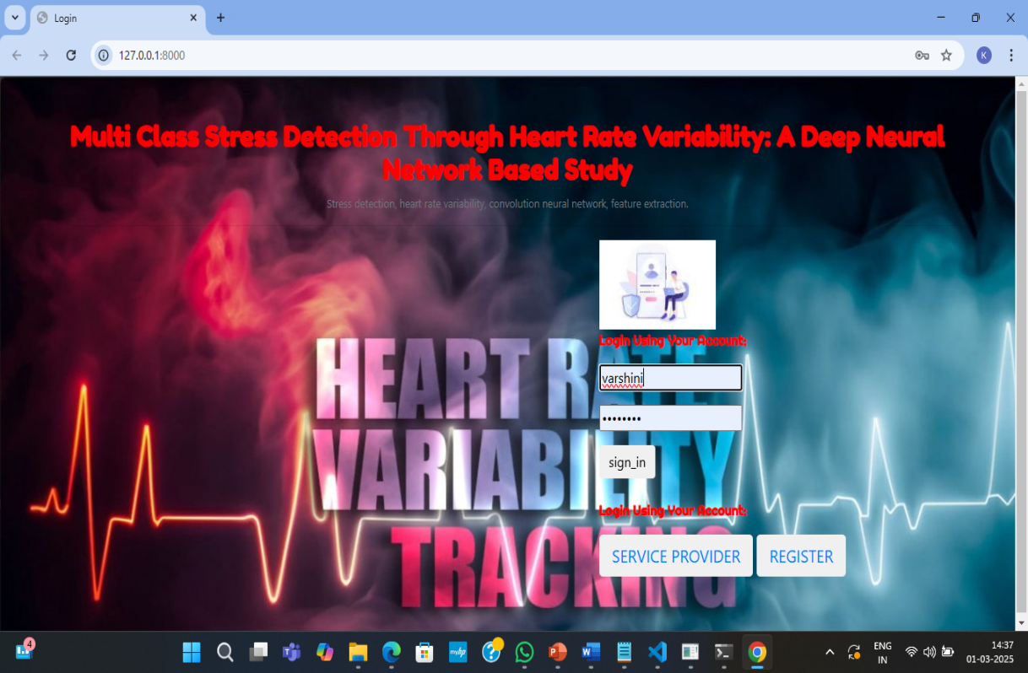

**Figure 5.1** GUI/Main Interface of multi class stress detection through

heart rate variability

**5.2 Remote User registration:**

The image displays a registration page for a "Multi-Class Stress Detection" system. Users enter details like username, email, gender, country, city, password, address, mobile number, and state. A "Register" button submits the form. The interface has a red-themed form over a heartbeat-tracking background, hosted locally at 127.0.0.1:8000.

.

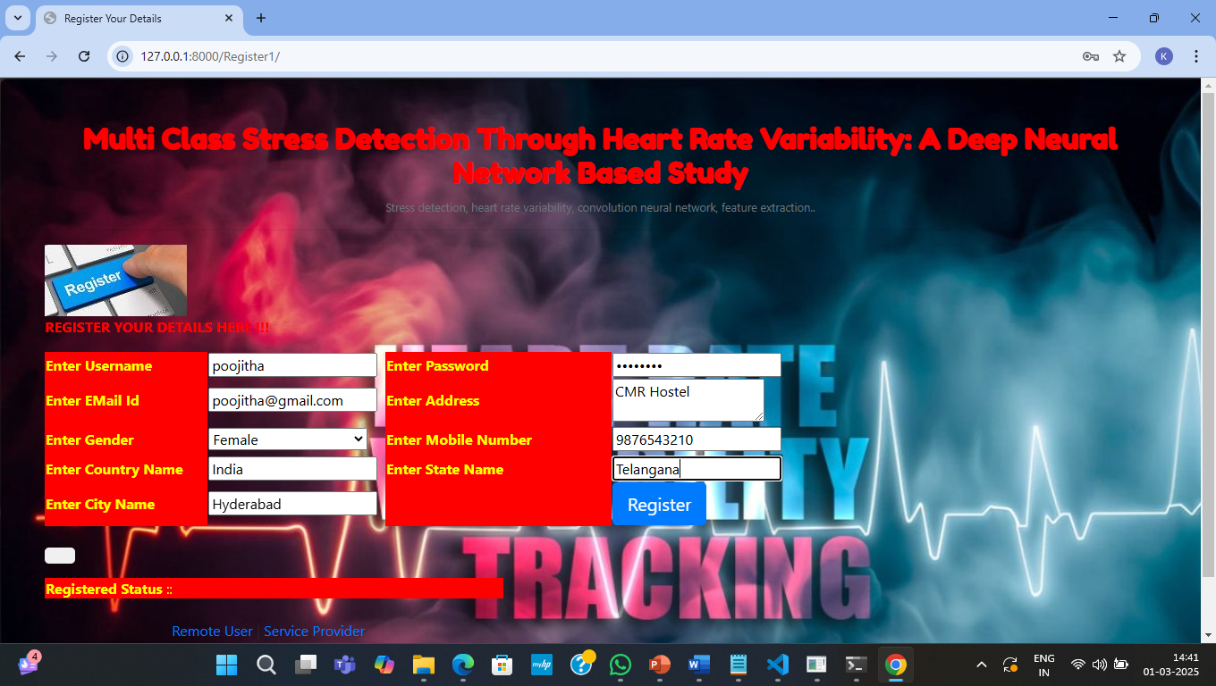

**Figure 5.2 :** Remote user registration in multi class stress detection through

heart rate variability

**5.3 Remote user login :**

The image shows a login page for the "Multi-Class Stress Detection" system using heart rate variability. A user named Poojitha is attempting to sign in by entering a username and password. There are options for service provider login and registration. The background features a heartbeat and stress-tracking theme.

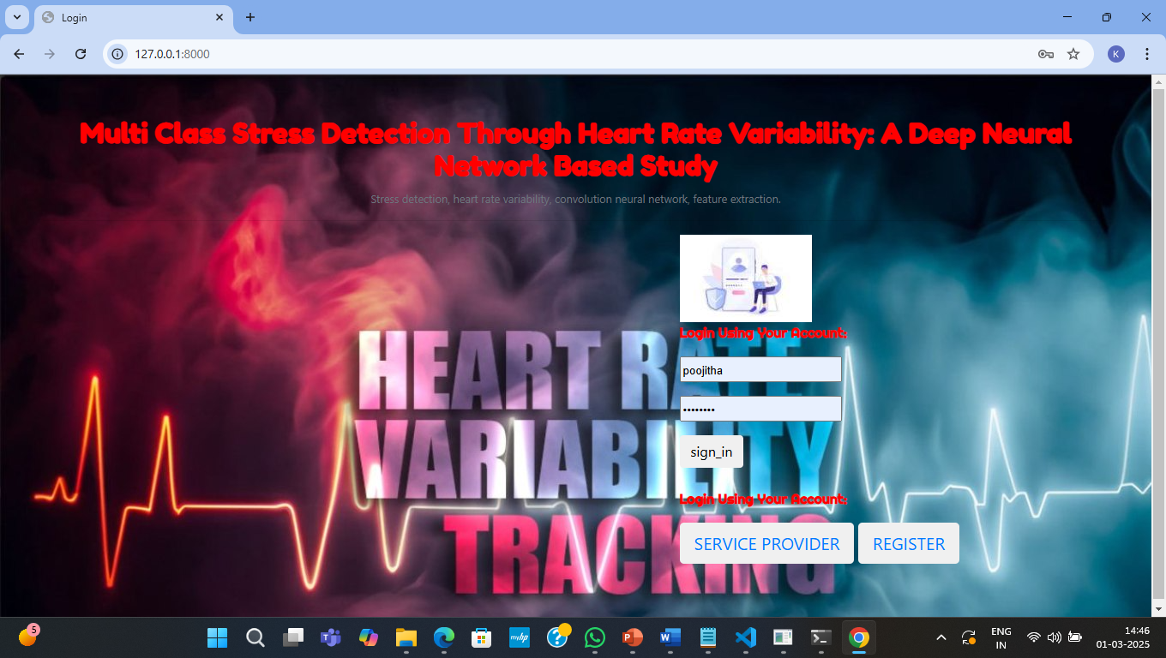

**Figure 5.3 :** Remote User login for multi class stress detection through

heart rate variability.

**5.4 Remote user profile view :**

The image displays a user profile page for the "Multi-Class Stress Detection" system. It shows registered details such as username, email, gender, mobile number, address, country, state, and city. Navigation buttons allow users to predict stress, view their profile, or log out. The interface has a red and black heartbeat-themed background.

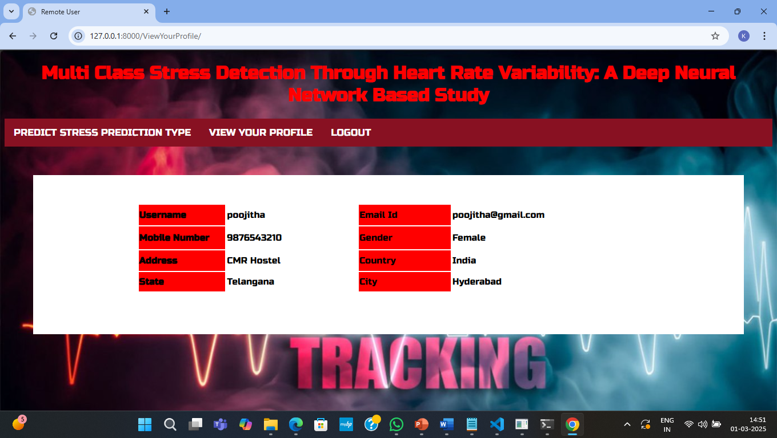

**Figure 5.4:** Remote user profile view in multi class stress detection through

heart rate variability.

**5.5 Predict the stress :**

The image displays a stress prediction input page for a Multi-Class Stress Detection System. Users enter various heart rate variability (HRV) parameters such as RMSSD, LF, HF, TP, and SD50 to predict stress levels. The system processes these inputs using a deep neural network-based model for analysis.

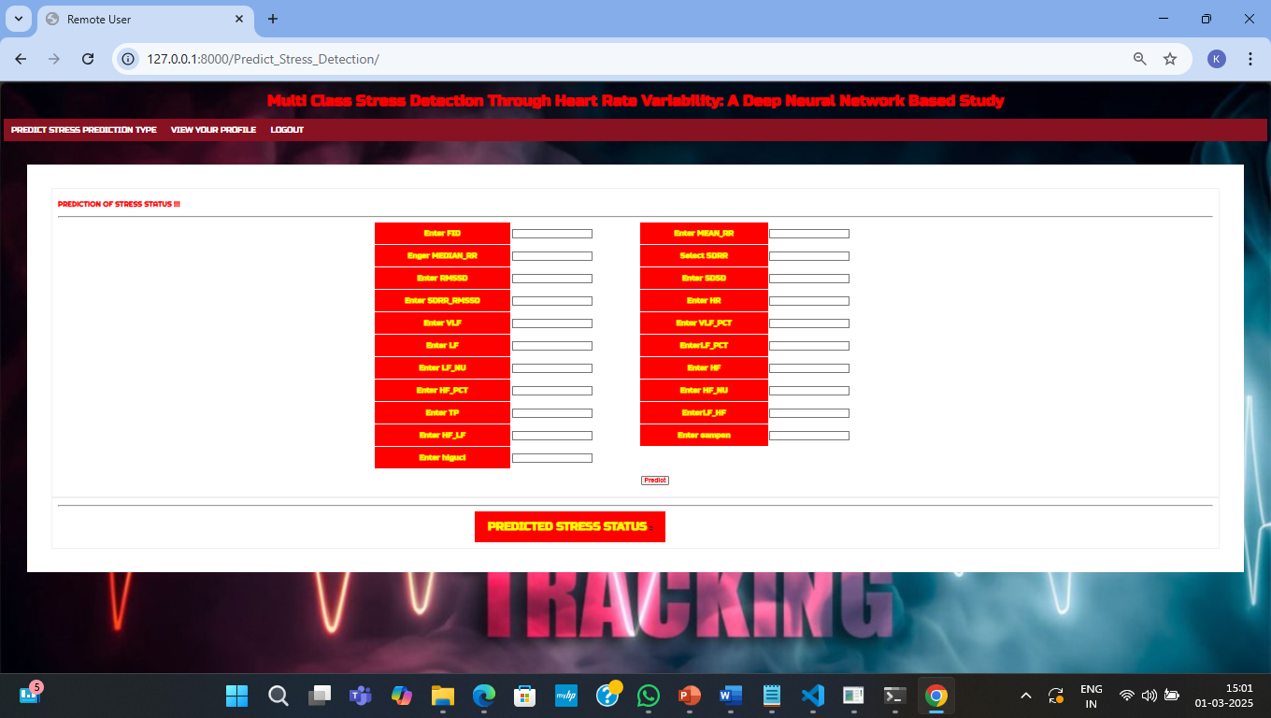

**Figure 5.5 :** prediction of stress in multi class stress detection through

heart rate variabilit

**5.6 Stress Detection :**

The image shows a stress prediction system using heart rate variability (HRV) parameters. Users input values like RMSSD, LF, HF, TP, and SDRR, and the system processes them using a deep neural network model to predict stress levels. A "PREDICTED STRESS STATUS" button generates the final output.

.

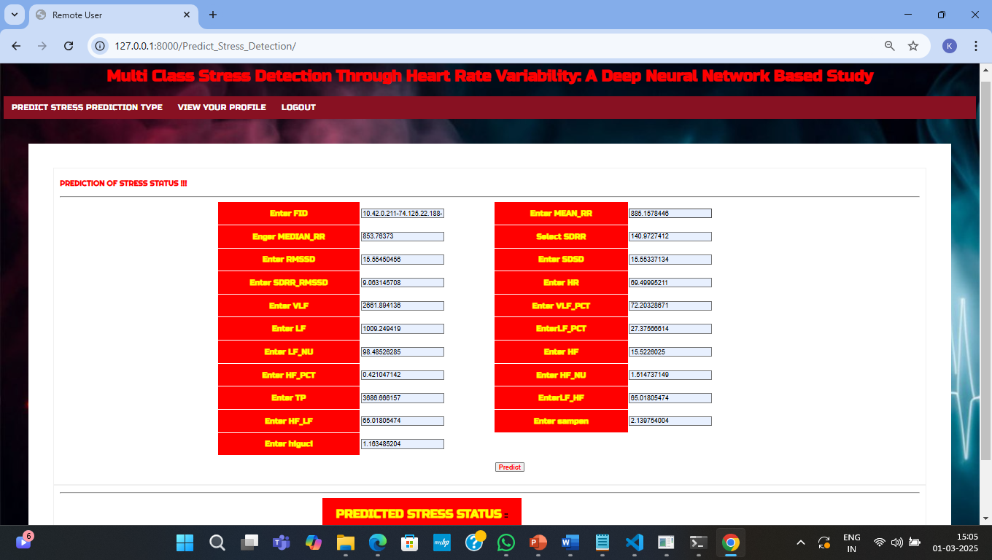

**Figure 5.6 :**  Stress detection using hrv features in multi class stress detection

through heart rate variability

**5.7 Service Provider login:**

The image displays a login page for a Multi-Class Stress Detection System based on heart rate variability (HRV) using a deep neural network. It includes fields for admin login credentials, a "Login" button, and an option for user login. The background features electrocardiogram (ECG) waves and smoke effects for visualization.

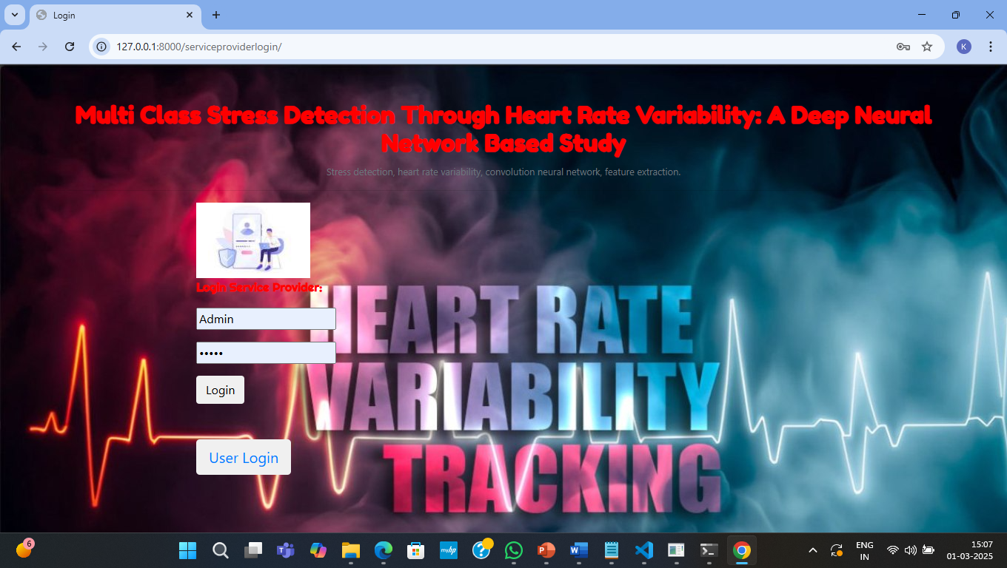

**Figure 5.7:**  Service provider login in multi class stress detection through

heart rate variability

**5.8 Remote Users:**

The image displays a remote user management page for a Multi-Class Stress Detection System. It lists users' names, emails, gender, addresses, mobile numbers, countries, states, and cities in a tabular format. The interface allows viewing, managing, and analyzing user data and includes various navigation options for dataset analysis and stress prediction results.

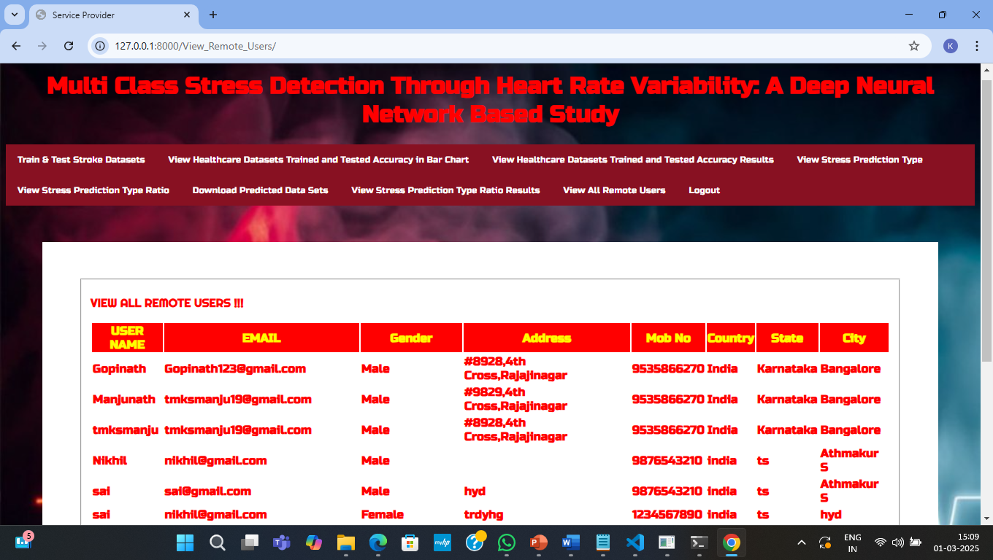

**Figure 5.8 :**  Remote users in multi class stress detection through

heart rate variability

**5.9 Accuracy in Bargraph:**

The image presents a bar chart comparing the accuracy of different machine learningmodels used for multi-class stress detection. The models include CNN (50.07%), SVM(52.92%), Logistic Regression (54.52%), and Decision Tree Classifier (54.38%). The interface allows users to view stress prediction results and dataset accuracy.

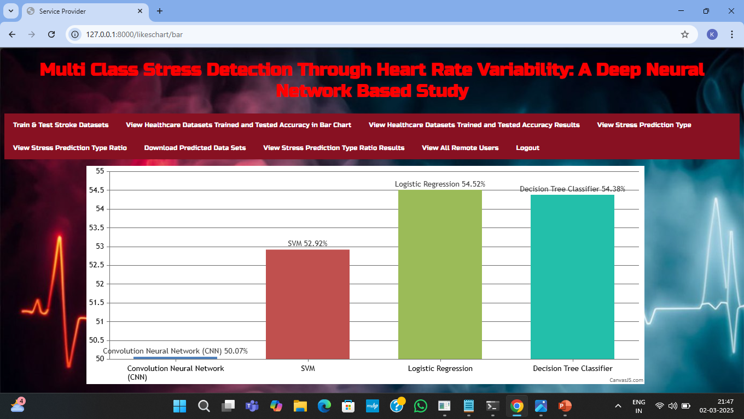

**Figure 5.9: representation of accuracy using different algorithms in bargraph in**

**multi class stress detection through heart rate variability.**

**5.10 Accuracy in linechart:**

The image displays a line chart comparing the accuracy of different machine learning models for multi-class stress detection. It shows CNN (50.07%), SVM(52.92%), Logistic Regression (54.52%), and Decision Tree Classifier (54.38%).The interface offers options to view stress prediction results and dataset accuracy analysis.

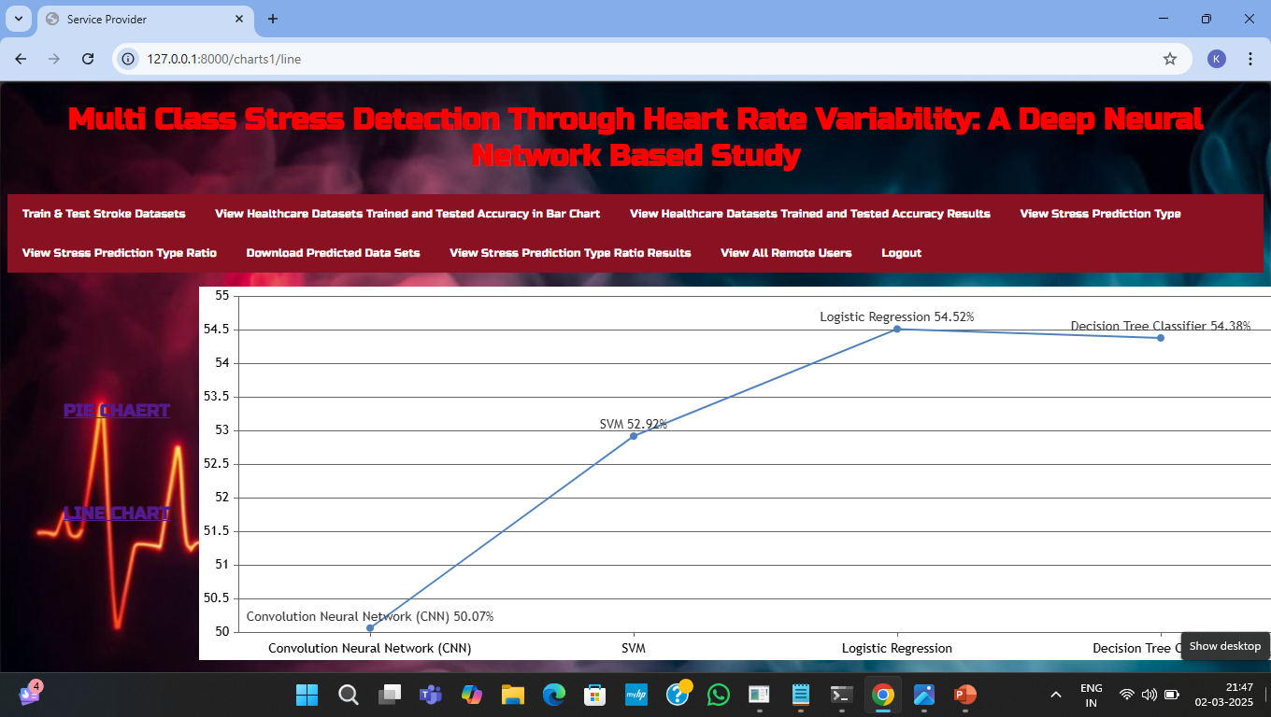

**Figure 5.12:representation of accuracy using different algorithms in linechart in**

**multi class stress detection through heart rate variability.**

**5.11 Existing predictions:**

The image shows a stress detection system interface displaying detailed stress prediction data. The table contains various physiological parameters like MEAN_RR, MEDIAN_RR, SDRR, RMSSD, HR, and VLF, linked to unique FIDs. These metrics help analyze heart rate variability for multi-class stress detection using machine learning techniques.

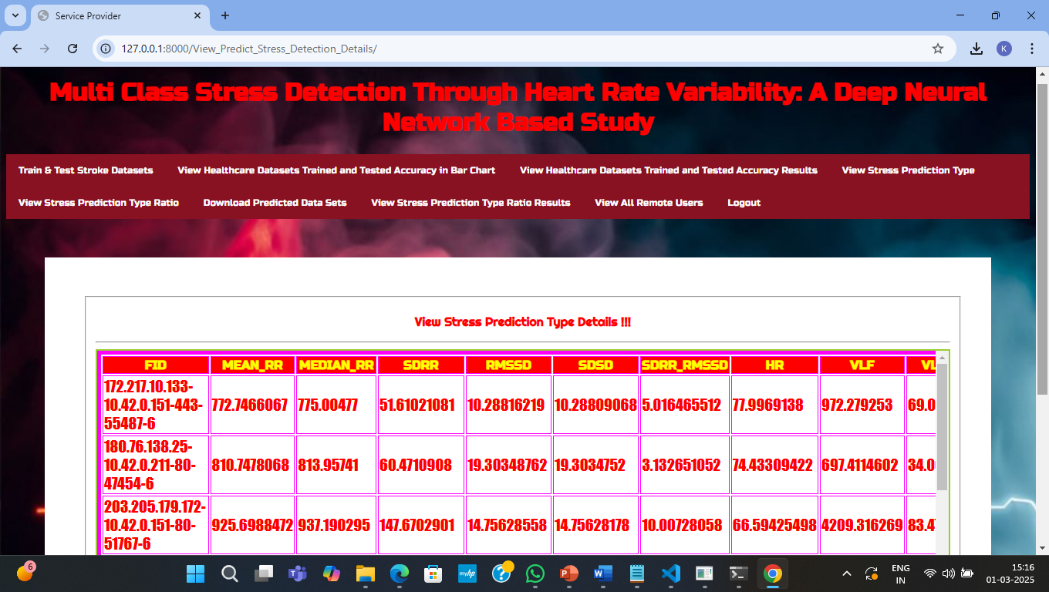

**Figure 5.11:** **All the previously predicted details in multi class stress detection**

**through heart rate variability.**

**5.12 Stress vs No Stress ratio:**

The image presents a stress prediction ratio analysis from a multi-class stress detection system. It shows the proportion of individuals classified as experiencing stress (26.67%) versus no stress (73.33%) based on heart rate variability data. The system uses machine learning to differentiate stress levels for healthcare and research applications.

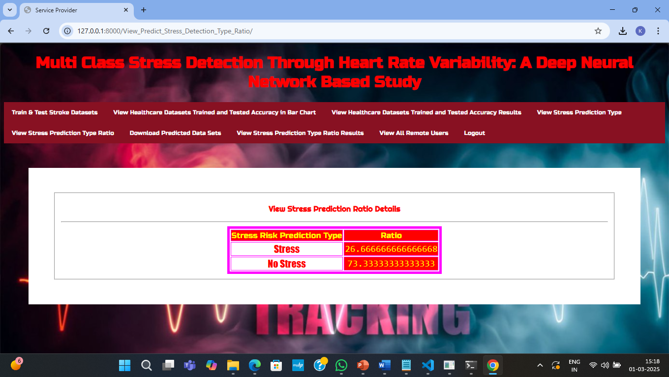

**Figure 5.12:** Stress vs No stress ratio in multi class stress detection through heart rate

variability.

**5.13 Stress vs No Stress ratio in pie chart:**

The image displays a pie chart representing the stress prediction ratio in a multi-class stress detection system. It shows 26.67% of users experiencing stress and 73.33% classified as no stress. The system analyzes heart rate variability (HRV) data using machine learning to differentiate stress levels effectively.

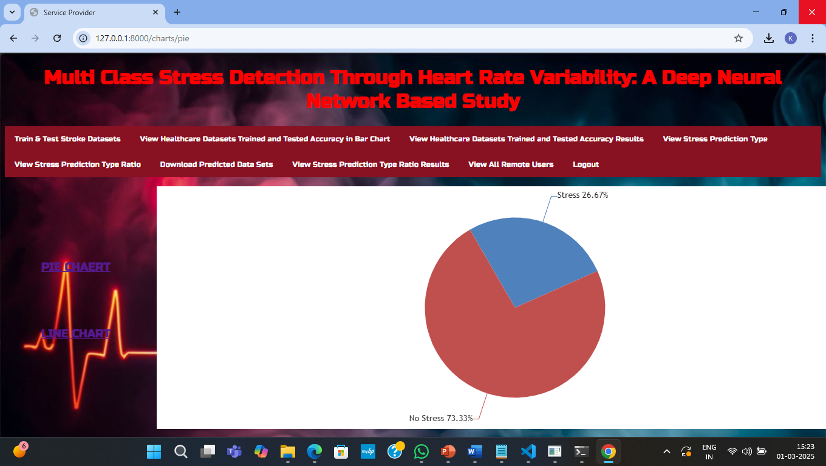

**Figure 5.13:** Stress vs No stress ratio representation in piechart in multi class stress

detection through heart rate variability

**5.14 Stress vs No Stress ratio in line chart:**

The image displays a line chart representing the stress vs. no stress ratio in a multi-class stress detection system. It shows 26.67% of users experiencing stress and 73.33% classified as no stress. The system uses heart rate variability (HRV) analysis to determine stress levels based on machine learning predictions.

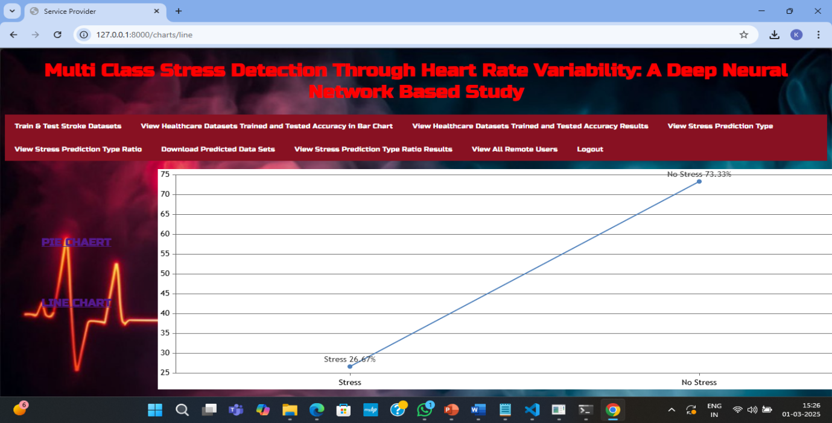

**Figure 5.14:** Stress vs No stress ratio representation in linechart in multi class stress

detection through heart rate variability.

**6.VALIDATION**

**6. VALIDATION**

The validation of this project primarily relies on extensive testing and well-defined test cases to ensure the accuracy and effectiveness of the multi-class stress detection system. The testing process involves multiple stages, including dataset validation, model performance evaluation, and real-world testing. By implementing a structured validation approach, we can ensure that the system consistently delivers high accuracy in detecting stress levels while minimizing misclassifications.

### INTRODUCTION

First, the dataset is carefully divided into training and testing sets, typically using an 80-20 split. The training set is used to train the logistic regression model, while the testing set evaluates its generalization ability. To enhance reliability, K-fold cross-validation is performed, ensuring that the system is tested on multiple data partitions. This method prevents overfitting and ensures that the model generalizes well to unseen data.

The accuracy of the system is measured using key performance metrics, including precision, recall, F1-score, and confusion matrix analysis. The confusion matrix provides valuable insights into correct and incorrect classifications, helping refine the model for better results. Additionally, the proposed logistic regression model is compared against existing classification models such as SVM, KNN, and Random Forest, demonstrating that the optimized feature selection enhances performance.

Finally, real-world deployment testing is conducted to simulate stress classification scenarios, ensuring that the system performs well with real physiological data. Continuous improvements are made based on test results, allowing the model to remain effective in real-time stress detection applications. This structured validation process ensures that the proposed system is reliable, scalable, and capable of maintaining high classification accuracy in practical applications.

### 6.2 TEST CASES

**TABLE 6.2.1 UPLOADING DATASET**

|  |  |  |  |  |
| --- | --- | --- | --- | --- |
| Test case ID | Test case name | Purpose | Test Case | Output |
| 1 | User uploads HRV features. | Use it for stress prediction. | The user uploads the HRV features, on which the stress or no stress is detected. | Dataset successfully loaded. |

**TABLE 6.2.2 CLASSIFICATION**

|  |  |  |  |  |
| --- | --- | --- | --- | --- |
| Test case ID | Test case name | Purpose | Input | Output |
| 1 | Classification test 1 | To check if the classifier performs its task | HRV values of stress are entered. | Stress. |
| 2 | Classification test 2 | To check if the classifier performs its task | HRV values of no stress are entered. | No Stress. |

**7.CONCLUSION & FUTURE ASPECTS**

**7. CONCLUSION & FUTURE ASPECTS**

The project has successfully achieved its objectives, demonstrating significant advancements in stress classification using HRV features. The implementation and validation phases were carefully designed and executed, resulting in improved accuracy and efficiency. By leveraging optimized feature selection and machine learning techniques, the proposed model outperforms existing methods while maintaining computational efficiency.

**7.1 PROJECT CONCLUSION**

A robust stress classification model has been developed using HRV features and validated for effectiveness based on the publicly available SWELL-KW dataset. Through extensive training and validation, the model demonstrates superior performance compared to state-of-the-art classifiers in key evaluation metrics, including Accuracy, Precision, Recall, F1-score, and MCC when utilizing an optimized feature set. By selecting the most relevant HRV features, computational complexity has been reduced while maintaining high classification accuracy, making the system efficient for practical applications.

Furthermore, our approach ensures scalability by minimizing the reliance on

resource-intensive computations, allowing for real-time stress classification. To further

enhance real-world applicability, we plan to explore optimization techniques that enable

seamless integration with edge devices, facilitating on-device stress detection for wearable

health monitoring systems. The success of this project paves the way for advanced, AI-driven

stress detection models, contributing to improved mental health management and well-being.

**7.2 FUTURE ASPECTS**

The proposed stress classification model presents promising opportunities for further advancements in real-time health monitoring and personalized stress detection. Future developments will focus on:

* Continuous HRV Monitoring with Wearables
  + Integration with smartwatches, fitness bands, and ECG patches for real-time HRV tracking.
  + Advanced signal processing techniques to enhance data quality and filter out noise.
* Edge Computing for On-Device Analysis
  + Local processing of HRV data on wearable devices to reduce latency and cloud dependency.
  + AI-powered models optimized for real-time stress classification directly on edge devices.
* Energy-Efficient & Adaptive Stress Detection
  + Development of optimized low-power AI models for efficient execution on wearable hardware.
  + Personalized stress thresholds based on individual HRV patterns to improve detection accuracy.
* Integration with Health & Telemedicine Platforms
  + Synchronization with mobile health applications for data visualization and stress management.
  + Secure remote monitoring capabilities for healthcare professionals to provide timely interventions.

By implementing these future advancements, the proposed model can evolve into a comprehensive, real-time stress monitoring solution, contributing to preventive healthcare and mental well-being on a large scale.

**8. BIBLIOGRAPHY**

**8. BIBLIOGRAPHY**

**8.1 REFERENCES**

[1] H.-G. Kim, E.-J. Cheon, D.-S. Bai, Y. H. Lee, and B.-H. Koo, ‘‘Stress and heart rate variability: A meta-analysis and review of the literature,’’Psychiatry Invest., vol. 15, no. 3, pp. 235–245, Mar. 2018.

[2]D. Muhajir, F. Mahananto, and N. A. Sani, ‘‘Stress level measurements using heart rate variability analysis on Android based application,’’ Proc.Comput. Sci., vol. 197, pp. 189–197, Jan. 2022.

[3] J. Held, A. Vîslă, C. Wolfer, N. Messerli-Bürgy, and C. Flückiger, ‘‘Heartrate variability change during a stressful cognitive task in individuals with anxiety and control participants,’’ BMC Psychol., vol. 9, no. 1, p. 44,Mar. 2021.

[4]K. M. Dalmeida and G. L. Masala, ‘‘HRV features as viable physiological markers for stress detection using wearable devices,’’ Sensors, vol. 21, no. 8, p. 2873, Apr. 2021.

[5]J. A. Miranda-Correa, M. K. Abadi, N. Sebe, and I. Patras, ‘‘AMIGOS: A dataset for affect, personality and mood research on individuals and groups,’’ IEEE Trans. Affect. Comput., vol. 12, no. 2, pp. 479–493, Apr./Jun. 2021.

[6] E. Won and Y.-K. Kim, ‘‘Stress, the autonomic nervous system, and the immune-kynurenine pathway in the etiology of depression,’’ Current Neuropharmacol., vol. 14, no. 7, pp. 665–673, Aug. 2016.

**8.2 GITHUB LINK**

https://github.com/dayanidhi46/MULTI CLASS STRESS DETECTION THROUGH HEART RATE VARIABILITY